Correlations

sammy waiyaki

November 7, 2019

# data loading  
AlzData <- read.csv(file.choose(), header = T)  
View(AlzData)  
attach(AlzData)  
  
# data exploration  
dim(AlzData)

## [1] 50 23

AlzData <- na.omit(AlzData)  
  
# correlations  
cor(Behavioral...Memory, Hippocampus.Plaque.Density)

## [1] -0.7515362

library(ggplot2)

## Warning: package 'ggplot2' was built under R version 3.5.3

qplot(Behavioral...Memory, Hippocampus.Plaque.Density, geom = c('point', 'smooth'), method = 'lm', main = 'scatter plot of Memory ability and Hippocampus plaque Density')

## Warning: Ignoring unknown parameters: method

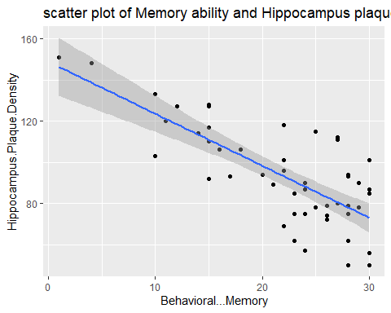

cor(Behavioral...Memory, Temporal.Plaque.Density)

## [1] 0.02315798

qplot(Behavioral...Memory, Temporal.Plaque.Density, geom = c('point', 'smooth'), method = 'lm', main = 'scatter plot of Memory ability and Temporal plaque Density')

## Warning: Ignoring unknown parameters: method

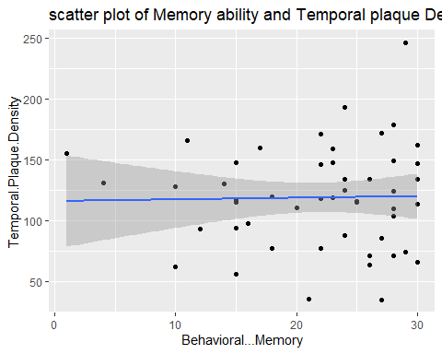

cor(Behavioral...Navigation, Hippocampus.Plaque.Density)

## [1] -0.3534729

qplot(Behavioral...Navigation, Hippocampus.Plaque.Density, geom = c('point', 'smooth'), method = 'lm', main = 'scatter plot of Navigational ability and Hippocampus plaque Density')

## Warning: Ignoring unknown parameters: method

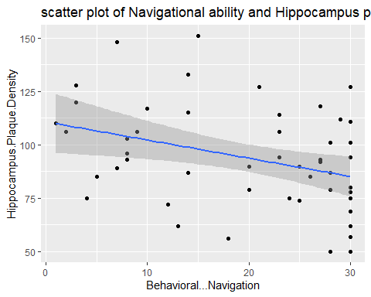

cor(Behavioral...Navigation, Temporal.Plaque.Density)

## [1] 0.01790631

qplot(Behavioral...Navigation, Temporal.Plaque.Density, geom = c('point', 'smooth'), method = 'lm', main = 'scatter plot of Navigational ability and Temporal plaque Density')

## Warning: Ignoring unknown parameters: method

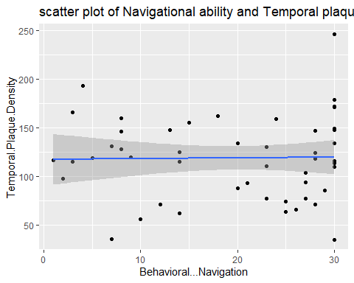

cor(Age, Hippocampus.Plaque.Density)

## [1] -0.04129472

qplot(Age, Hippocampus.Plaque.Density, geom = c('point', 'smooth'), method = 'lm', main = 'scatter Age and Hippocampus plaque Density')

## Warning: Ignoring unknown parameters: method

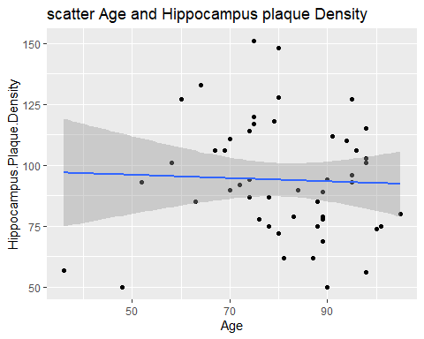

cor(Age, Temporal.Plaque.Density)

## [1] 0.08751625

qplot(Age, Temporal.Plaque.Density, geom = c('point', 'smooth'), method = 'lm', main = 'scatter plot of Age and Temporal plaque Density')

## Warning: Ignoring unknown parameters: method

